Q1. Consider the following data for stocks A and B:

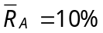; 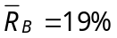; 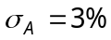; 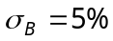; 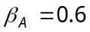; 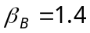; 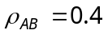

- Calculate the expected return, variance, and beta of a portfolio constructed by investing 1/3 of your funds in stock A and 2/3 in stock B.
- If the riskless rate of return were 5%, what percentage of money invested in risky stocks should an investor place in each stock (assuming A and B are the only risky assets available)?
- If the Security Market Line describes equilibrium, and stocks A and B are in equilibrium, what is the return on the market portfolio and the riskless rate of interest?
- If an investor can lend and borrow at the riskless rate determined in part c, but is restricted to holding only one of the two risky stocks in this problem, which stock should be held?

Q2. You use the single-factor model R_{it} = α_{i} + β_{i} R_{mt} + e_{it} and have obtained the following estimates for stock A and stock B:

stock α β σ_{e}

A 2% 1.3 30%
B 10% 1.2 40%

You also estimate that the expected return on the market portfolio is 16%, the standard deviation of the market portfolio is 20%, and the riskless rate is 8%.

a. Based on the single-factor model, what are the expected returns and
standard deviations of stock A and stock B?
b. Based on the single-factor model, the Security Market Line, and the
Capital Market Line, state whether each of the following statements
completely true, completely false, or uncertain. Explain your answers.

1) In any given year, stock B is certain to outperform stock A.
2) An investor would consider stock B to be riskier than stock A.
3) Stock A is undervalued.
4) If an investor had to select one investment to combine with the
riskless asset, the investor would prefer stock A to the market
portfolio.

